EIN # 82-1492587

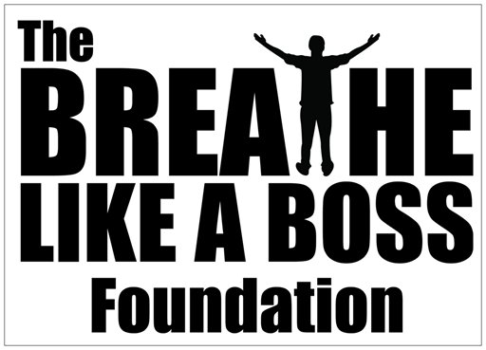

2018 GRANT APPLICATION
All information below must be completed and included to be considered

- Application Signed and completed

- Photo and Short Essay

- Signed Consent and Disclosure

Pysician or Social Worker Letter

The Breathe Like A Boss Foundation Grant Application Info and Qualifications:

- Anyone who is over the age of 18 and suffers from a genetic respiratory ailment such as Cystic Fibrosis, or is a Post Transplant Patient can apply.

- Post Organ Transplant Recipients do not have to have had a Double Lung Transplant to qualify.

- The Breathe Like A Boss Foundation is not able to approve all Grant requests. Applications will be voted on by board members. If not accepted you can reapply every 3 months.

- Applicants must reside in California or Illinois.

- Applications are reviewed every 3 months or sooner, and each applicant will be interviewed via phone, facetime, or skype before approval.

- The Breathe Like A Boss Foundation will directly pay for the particular extra curricular activity or program to the company or organization directly if possible. If applicant is already in a contract or paying for that particular gym or program, please provide us with proof of payment or said contract. If approved we may reimburse you for the costs that you are requesting.

- If applicant is requesting fitness or exercise equipment, The Foundation will purchase said equipment if approved. Assembly and delivery is not always included.

By signing here I agree I meet all of the above criteria:

______________________________________________________Applicant’s name

_____________________________________________________
Applicant’s signature

Application

Date:____________________

First name: Last name:
Address:
City: State: Zip:
Phone: ( ) .
E-mail:
Age: Date of Birth / /

- Have you applied for a grant with us in the past? No Yes

- What is your diagnosis, and when were you diagnosed?______________________________________________________________________________________________________

- What is your current ANNUAL household income?
(Please provide proof of income- either by sending in a copy of last years tax returns or proof that your are currently unemployed, in financial distress, or on disability)

- Are you currently on disability or receiving SSI? ________________________________

Consent

By signing here I authorize The Breathe Like A Boss Foundation or anyone associated with them to verify the information I provided, and allow them to discuss and confirm my situation with my healthcare providers if needed.

Signature:

Activity Request Information

Please be as specific as possible when providing the following information.

What kind of Fitness related Program, gym member ship, or extra curricular activity would you like to request? (i.e., Gym membership, martial arts, boxing, yoga classes, etc.):
__________________________________________________________________________________________________________________________________________________________________________________________________________________________________________

If you prefer exercise equipment please describe or provide a name of said equipment and were it may be sold? ____________________________________________________________________________________________________________________________________________________________________________________________________________________________________________________________________________________________________________________________________________________________________________________

Please provide us with a name of the business or organization and a contact number of owner or manager of establishment or program:
__________________________________________________________________________________________________________________________________________________________________________________________________________________________________________

Contact Person (if applicable):

Photograph

Please include a Photo of Yourself

Why are you a good candidate to receive a Grant from THE BREATHE LIKE A BOSS FOUNDATION? And how do you think it will help you? (Please provide a detailed explanation in an essay form)

By signing here, I agree that in consideration of the benefits I may receive, I hereby assume all risks of damages or injury, including death, that I may sustain while participating in or as a result of, or in any way growing out of any activity associated with The Breathe Like A Boss Foundation or it’s grants.:

/ /
Applicant’s Signature Date

*Please contact, Nick Di Brizzi or Dan Mayid, with questions at: thebreathelikeabossfoundation@gmail.com or call 818-264-8784

Physician or Health Care Provider Information

Doctor’s Name:
Doctor’s E-mail:
Medical Facility or Care Center:
Hospital Mailing Address:
City: State: Zip code:

Contact Person:
Phone: ( ) E-mail :

PLEASE HAVE YOUR DOCTOR, SOCIAL WORKER, OR NURSE PRACTITIONER WRITE A LETTER OR A BRIEF STATEMENT WITH YOUR DIAGNOSIS AND HOW YOUR SPECIFIC REQUEST WILL BENEFIT YOUR OVERALL HEALTH ,

